Task 2.1P: Sending Temperature and Light Data to the Web
  - SIT210 — Embedded Systems Development
  - Emilio Joseph Calma (s223976317)

1. Webhook Summary
A webhook is a mechanism that allows one system to automatically send data to another system when a specific event occurs. Rather than continuously polling for updates, the sending device pushes data directly to a web endpoint using an HTTP POST request. In this embedded systems solution, the Arduino Nano 33 IoT acts as the sender, it reads temperature and light sensor data and sends it directly to ThingSpeak's API endpoint every 30 seconds. This follows the same webhook principle: the device initiates the data transfer when an event occurs (in this case, a timed interval), without waiting to be asked.

Webhooks are widely used in real-world applications such as payment gateways notifying merchants when a transaction is completed, GitHub notifying CI/CD pipelines when new code is pushed, and smart home devices reporting sensor readings to cloud dashboards. In this solution, the sendToThingSpeak() function is responsible for sending the sensor data to the web. It uses the ThingSpeak library to construct and send an HTTP POST request to ThingSpeak's API, which is exactly the mechanism described above, data is pushed from the device to a web endpoint automatically, without any manual intervention.

2. Circuit Schematic
The circuit was built using an Arduino Nano 33 IoT, a DHT11 temperature and humidity sensor, and a Keyestudio LDR light sensor module. The schematic was created using Tinkercad.

Tinkercad Circuit Link: https://www.tinkercad.com/[your-tinkercad-link]

Wiring Summary

Component | Arduino Pin | Notes
DHT11 VCC | 3.3V (via rail) | Power from breadboard positive rail
DHT11 GND | GND (via rail) | Ground from breadboard negative rail
DHT11 DATA | D2 | Temperature data pin
LDR V (VCC) | 3.3V (via rail) | Power from breadboard positive rail
LDR G (GND) | GND (via rail) | Ground from breadboard negative rail
LDR S (Signal) | A0 | Analogue light reading pin

3. ThingSpeak Channel
A ThingSpeak channel named RoomConditions was created with two fields:
- Field 1: Temperature — reads temperature in Celsius from the DHT11 sensor
- Field 2: Light — reads analogue light level (0-1023) from the LDR sensor

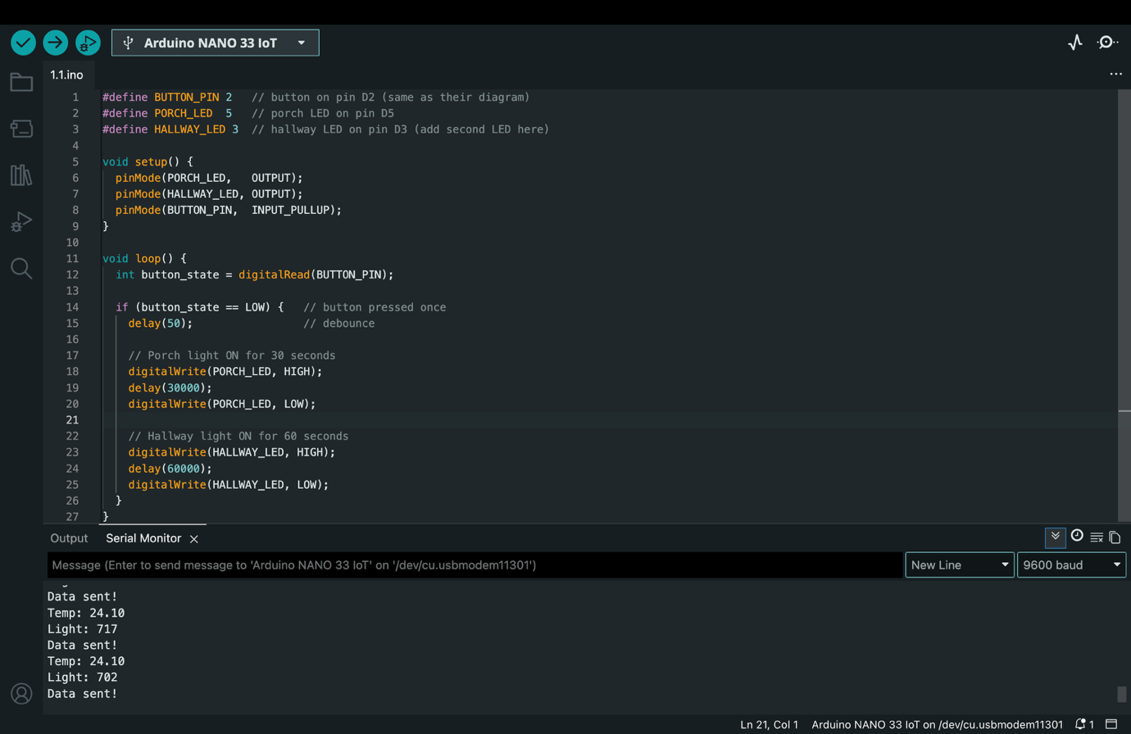
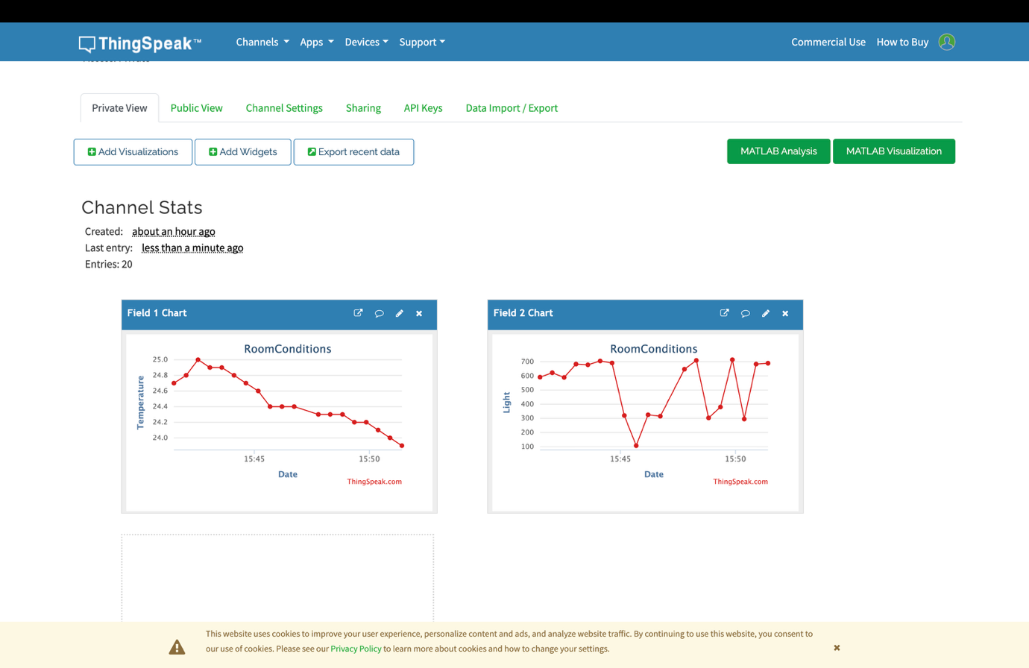

4. GitHub Repository
The complete code for this task is available in the GitHub repository at the following link:

Repository Link: https://github.com/[your-username]/SIT210/tree/main/Task2.1WebHook

The repository folder Task2.1WebHook contains the Arduino source code file which reads temperature from the DHT11 sensor and light level from the LDR sensor, then sends both values to ThingSpeak every 30 seconds using modular programming.

5. ThingSpeak Graph 5 Minute Reading
The graph below shows both temperature and light readings recorded over a period of approximately 5 minutes. Artificial variation was introduced in the light readings by covering and uncovering the LDR sensor with a hand, and shining a torch directly on it, to demonstrate the sensor responding to changes in room luminosity.



The temperature graph shows a gradual natural decline in room temperature over the recording period. The light graph shows significant variation between approximately 100 and 700, demonstrating the LDR sensor accurately detecting changes in light levels in real time.

